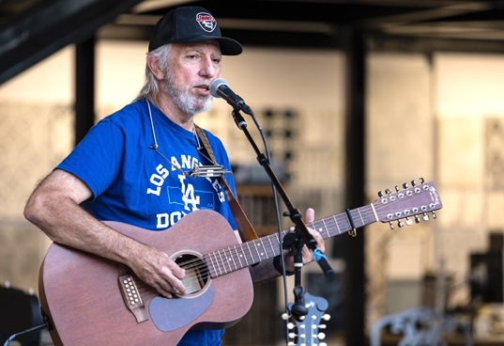
Mike Berman
Singer/songwriter
mikebermanmusic@gmail.com
+1 818-434-3520

Mike Berman writes and performs original songs rooted in the folk and California folk rock traditions. Mike’s first album Where I’m From, released in January 2023, received excellent reviews and was featured on dozens of folk radio programs across the USA and beyond. He has performed concerts and showcases at venues across Southern California, such as The Coffee Gallery, The Lost Chord, Jeweled Universe, Universal Bar & Grill, Mission Tile Music, Stardust Concerts, and many other venues, both solo and with his three-piece combo TIMBR. He has appeared at legendary venues McCabe’s Guitar Shop in Los Angeles, the Towne Crier in Beacon, New York, and Club Passim in Boston. He’s also been a regular performer at on-line showcases including Bruce Swan’s Music My Mother Wouldn’t Like, Jan Seides “Any Sunday Songwriters” series, and his own Social Distance Café. He recently was awarded “Best Performance” at the Songwriters at Play competition in Solvang, California.
Mike’s album Where I’m From was in the top thirty on the NACC charts in January 2023. Produced by Ed Tree, the album featured performances from top musicians including pedal steel legend Jay Dee Maness, 2-time Grammy nominee Guy Davis, and LA blues diva Teresa James. Dave Franklin of Dancing About Architecture wrote that “Where I’m From is a great album… the sound of a modern-day James Taylor… country cool for the modern age.” Legendary songwriter Steve Gillette commented that Mike’s songs “uphold the tradition and are evidence that the California sound is in good hands.” Songwriter Rob Waller, founder of “I See Hawks in LA”, says that “Mike’s songs carry a depth and humanity that stick with you.”

Mike is a veteran musician, having performed in the 80’s with the Hudson River Sloop Singers as well as in his duo The Rusty Lock String Band, including festival gigs at the New Jersey Folk Festival and the Raritan River Festival. After a long layoff to raise a family and build a career as a university administrator and information technology expert, he has dived head-first in songwriting in the last few years. His songwriting his developed through workshops and master classes with the likes of Richard Thompson, Tom Paxton, Patty Griffin, Shawn Colvin, Guy Davis, Ellis Paul, Laurie McAllister, Gretchen Peters, and many other accomplished songwriters and performers. He is currently recording new material for release in 2024.

Linktree: linktr.ee/mikebermanmusic
Email: mikebermanmusic@gmail.com
Phone/Text: 818-434-3520
Website: Mikebermanmusic.com
YouTube: Youtube.com/@mbermanmusic
Facebook: facebook.com/mikebermanmusic
Streaming links: mikeberman.hearnow.com/where-im-from
Performance Schedule: BandsInTown
Updated 1/1/2024

